Co-located Event: Manufacturing Productivity Technology Centre (MPTC)
Annual Conference 2016

· The Future of Manufacturing ·

12 - 14 October 2016, Singapore
Suntec Singapore Convention & Exhibition Centre

Virtual
Industrial
Automation (IA)

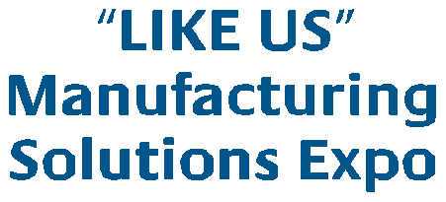Robotics

SMART Devices

Cloud
Computing

Automation

F
n

INDUSTRY 4.0

Digital actory (DF)

Data Analytics

Data Performance Indicator

Sustainable
Environment (SE)
Eco Friendly

Recovery

KEY FEATURES
Business Advisory Clinic for SMEs

Big Data

Packaging
Logistics

Operation
Government Pavilion
Additive Manufacturing
& Robotics Showcase Emerging Solutions Showcase ManuTech Xchange
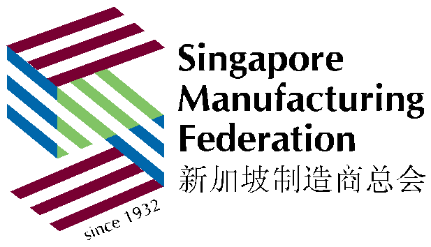Industry 4.0 Gallery (NEW)

Supply
Chain (SC)

ycling

Rec
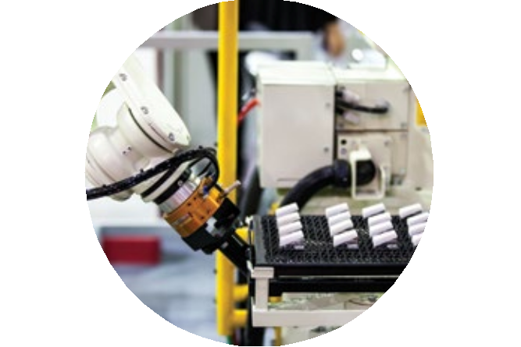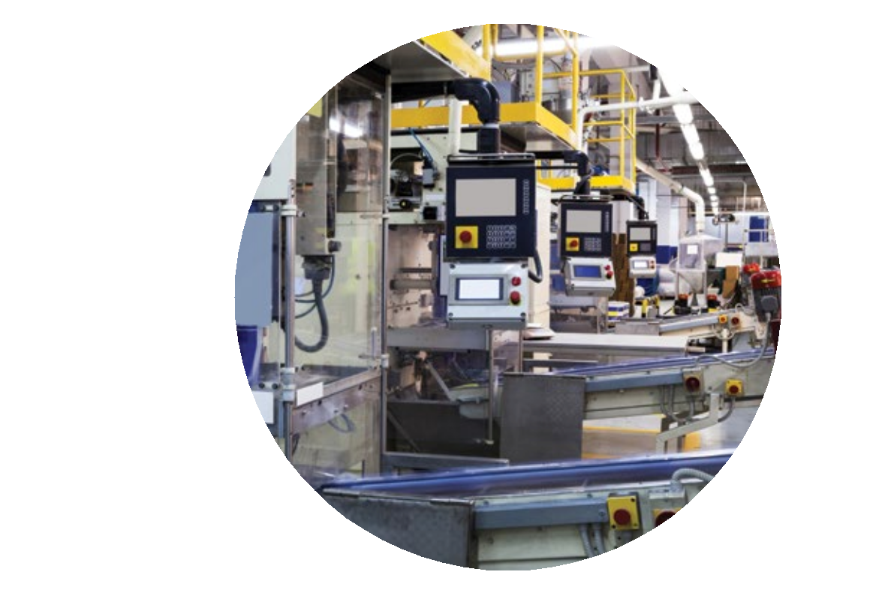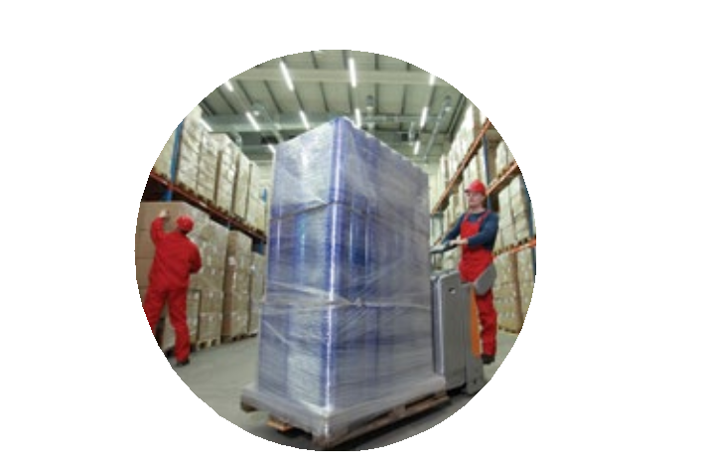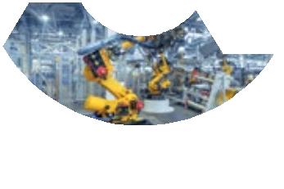

Organised by: Partner:

SIMTech
The High Value Manufacturing
Solutions in the ASEAN Region

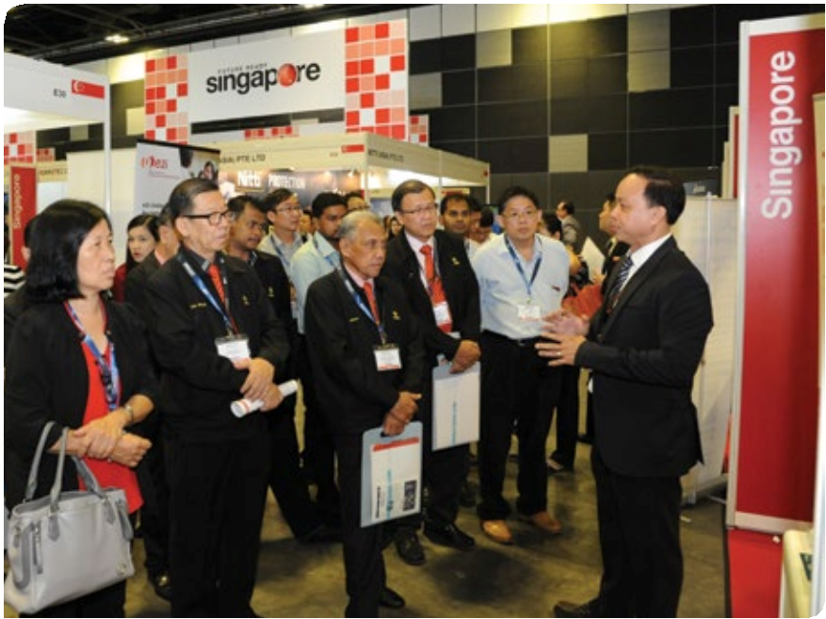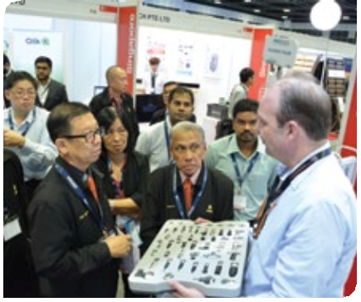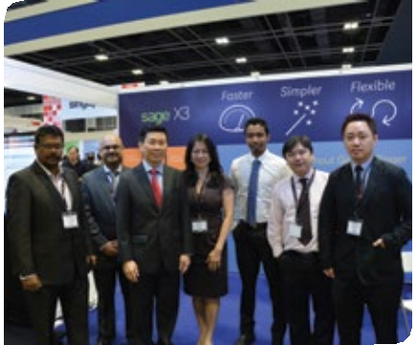Manufacturing Solutions Expo (MSE) 2016 – The Future of Manufacturing is an annual one-stop exhibition platform for products and solution providers to showcase innovative solutions, cost effective technologies and products to improve business productivity and efficiency within and beyond manufacturing industries.

Organised by Singapore Manufacturing Federation and SPHERE Exhibits Pte Ltd, this premier trade exhibition provides abundant opportunities to meet, network and discuss business through many co- located events and on-ground activities.

SLOVAKIA
The Future of Manufacturing
MSE 2016 invites manufacturers across Asia and the rest of the world to discover the boundless possibilities in the growth of manufacturing.

The 3rd edition of MSE 2016 will position itself as one of the MUST attend trade exhibitions in ASEAN. MSE 2016 expects to host more than 100 International and regional brands by exhibitors from over 20 countries, unveiling the latest manufacturing methods and techniques to improve business productivity across the industries. The trade show is expected to draw in 4,000 local and international trade visitors and will be a platform for buyers and sellers to explore business opportunities.

A series of onsite activities will be scheduled at the exhibition. MSE 2016 will offer the most comprehensive business platform leading to the future of manufacturing.

Business Advisory Clinic for SMEs

Facts and Figures – MSE 2015
Dates | 30th September to  2nd October 2015
Gross Exhibition  Space | 4,000 sqm
No. of Exhibitors | 77
No. of Brands | 115 (84 International  / 31 Local)
No. of Attendees | 3,336
No. of Participating  Countries | 23

Government Pavilion

Additive Manufacturing & Robotics Showcase

Emerging Solutions Showcase

ManuTech Xchange

Industry 4.0 Gallery (NEW )
34%

Business Matching Session

Increase in visitorship as compared to MSE 2014
Regional Industry Updates at a Glance:

GLOBAL SMART FACTORY MARKET

Reaching at a
CAGR of 6%

2014
2020
Expected to reach nearly $67 billion

Experience the Future of Automated Manufacturing
• High level factory automation with the help of a flexible network of cyber-physical systems (CPS)

Industries that are Adopting Smart Factory Technologies:
- Automotive
- Electrical and Electronics
- Materials
- Mining
- Food and Beverages
- Pharmaceutical
Increase production output and improve safety of their employees and equipment

Emerging in Adopting the Technologies
Source: Research and Markets: Smart Factory Market By Technology, Applications & Geography – Global Forecast to 2020, January 15, 2015

PARADIGM SHIFT IN MANUFACTURING

• Automative |  | • Companies focus | • Cost effective | • Giant player in | • Biggest population
Manufacturing |  | on higher end of | • Easy access to | ASEAN | • Long-term potential
Centre |  | manufacturing | regional supply chain | • Low cost for supplies | • Attract foreign
• Strength in Vehicle  Production |  | value chain  • Government funded programme | • Low cost for  expansion  • Highly educated personnel | and labour  • Global presence | investment and  Higher-tech Manufacturing Capability
Thailand |  | Singapore | Malaysia | India | Indonesia

Source: The Future of “Future Asia”: the smart money is on ASEAN, www.odgersberndtson.com

THE NEXT BIG THING IN THE MANUFACTURING INDUSTRY

Key Market Trends Growing Markets CAGR Growth
Asia Pacific

Internet of Things Global 3D Printing Market Big Data
Service Robotics

SMART Factory

Global

Asia Pacific

Global

Global

• By Technology (PLM, MES, Industrial
Automation)
• Applications (Automotive, Electrical and Electronics, Materials and Mining, Food And Beverages, Pharmaceuticals,
& Others), & Geography
52.7% (2014 – 2020)

45% (2014 – 2019)

43% (2015 - 2020)

21.5% (2014 – 2020)

6% (2014 – 2020)
Expecting $67 Billion
Source: Enterprise Innovation / Solarplaza Press Release / PR Web / Research and Market - Asia Pacific Big Data Market 2015-2010
Markets and Markets: Smart Factory Market worth $67 Billion by 2020
Discover the Innovative Solutions & Technologies in the
Value Chain that Leads to the Future of Manufacturing

Presenting a diverse range of exhibit profile, this premier three-day trade show brings together the regional industry players and global leading brands under one roof!
Exhibit Profiles

Digital  Factory (DF) | • Additive Manufacturing  • Asset Management System  • Cloud Computing | • Product Lifecycle Management (PLM)  • Rapid Prototyping and Manufacturing  • Virtual Commissioning
 | • Enterprise Resource Planning (ERP) | • Virtual Product Development (CAx)
Integrated | • Manufacturing Execution Systems (MES) | • Virtual Reality
Framework
 | Automation Technology and IT | Production and Process Automation

Industrial
Automation (IA)

Automated
Solutions

Environmental
Technologies
• Cyber Physical Systems
• Internet of Things (I oTs) / M2M
• IT Security
• Product and Trademark Protection
• Security Technology

• Industrial Cleaning Solutions
• Industrial Cooling Solutions
• Assembly and Handling Systems
• Cables and Energy Carriers
• Components for Automation Systems and
Equipment
• Connection/ Interface Technology
• Electric Power Transmission/ Motion Control
• Engineering, Maintenance, Services
• Image Processing Sensors
• Instrumentation (Measurement and Control)
• Lasers
• Linear Drives
• Pneumatic Automation Technology
• Process Analysis Technology
• Pumps, Valves and Systems
• Robotics & System Integration
• Vibration Measurement Systems

• Thermal Rooms
 | • Clean Rooms | • Industrial Waste Collection
Sustainable  Environment (SE) | • Coordinate Measuring Machines (CMM) Roo | m • Materials Recovery & Recycling
 | • Control Rooms | • Pollution Control Technology
 | • Energy Management Systems / Services | • Power Systems
 | • Environment Management | • Renewable Energy & Alternative Fuels

• Waste Management Services

Supply
Chain (SC)

Logistic
Solutions
Lift & Move
• Industrial Trucks & Forklifts
• Lifting Platform
• Mechanical Handling Equipment
• Remotely Operated Transportation Systems
• Shelf Storage & Retrieval Equipment
• Vertical Lifting Equipment

Pick & Pack
• Labelling Systems and Identification
• Packaging and Order Picking Systems
• Packaging Materials
• Packaging Technology
• Scales and Metering Devices
Logistics IT
• Application Software
• Computer Systems and Controls
• Identification Technology

Store & Load
• Conveyor Systems
• Eco-Palleting System
• Loading Systems
• Mechanical Handling Systems
• Racking System
• Robots and Handling Systems
• Supply Chain Management
• Turnkey Systems for Logistics
• Warehousing Management System

Manage & Service
• Business Consultancy
• Logistics Management
• Maintenance and Servicing
• Real Estate & Sites for Logistics Operations
• Space Solution Providers
• Transportation Services
Increase Productivity, Sustainability to Gain Competitive
Advantage

Who will be visiting MSE 2016?
Take advantage of the high-level gathering and networking of the regional decision-makers and buyers at Manufacturing
Solutions Expo 2016.

Primary Industries
• Aerospace
• Automotive
• Biotechnology
• Electrical & Electronics
• Energy
• Food & Beverage

• Manufacturing
• Medical Technologies
• Healthcare
• Oil & Gas
• Telecommunication

Other Industries

• Chemical
• Construction
• Metal Component and Manufacturing
• Molds and Dies

• Parts Manufacturing
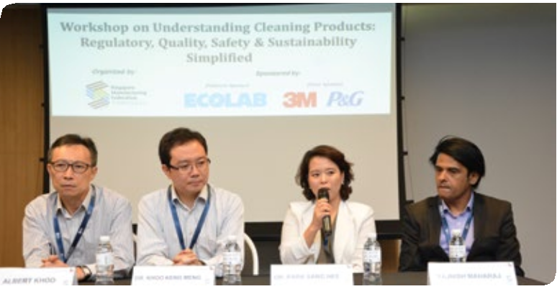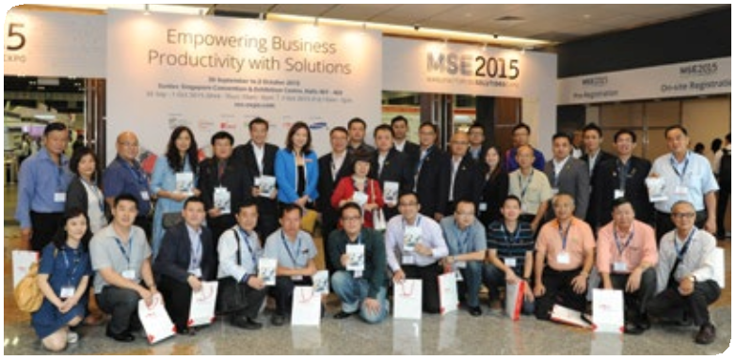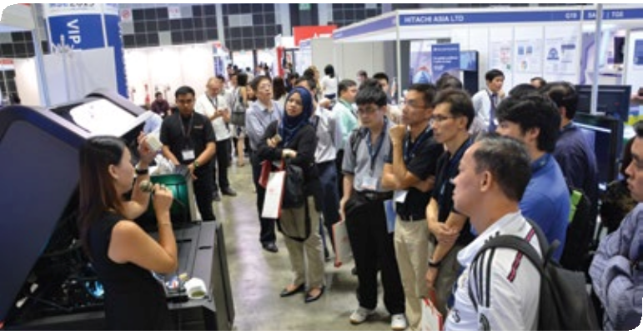• Retail & Wholesale
• Technology
• Transportation

Trade Professionals / Visitors

• Agent / Distributor / Trader
• Engineering (Machinery / Equipment)
• Environmental Management
• Design & Development
• Human Resources / Finance / IT
• Management Planning
• Material Handling / Logistics

• Material Testing
• Operations
• Purchasing & Sourcing
• Production & Processes
• Quality Control & Assurance
• Research & Development

90%

Exhibitor Testimonials

Exhibitors Generated Good Sales Leads

“MSE 2015 was a great opportunity for Brady to showcase our Track
& Trace, Automation, Product Identification and Brand Protection
solutions that are targeted at the manufacturing industry. We received plenty of interest and inquiries about our solutions and how they can actually help companies work smarter and more efficiently. MSE 2015 is a great platform for us to showcase our solutions to potential customers in the region and we would be
more than happy to be a part of it again in the next edition.”

MR. CHENG YOU JIE
Brady Corporation Asia Pte Ltd
MSE 2015

“HIWIN supports MSE since day one and presented a full range of exhibit products during the show. We are pleased to have attracted and interacted with the new potential clients & HIWIN customers to showcase our latest products; in which has created a high-level of brand awareness on-site. As such, the campaign has attracted a few hundred of quality visitors and has met our expectation generated over 100 potential sales leads after the event. We look forward to participating for
the next edition.”

MR. NICK ZHANG HIWIN Singapore Pte. Ltd MSE 2014 & 2015
“Hikari Automation had participated in MSE exhibition since 2014 and it had been a truly wonderful and fruitful experience. By choosing this exhibition as a platform, we are able to unveil and showcase the latest products and technology solutions from our Factory Automation distributed brands as well as generating new sales leads and establishing a better connection with our existing customers.
Customers had mostly feedback positively and are keen on using our products in their system after our on-site demo and explanation. We look forward to be a part of MSE2016!”

MR. ROY CHEW
Hikari Automation Systems Pte Ltd
MSE 2014 & 2015
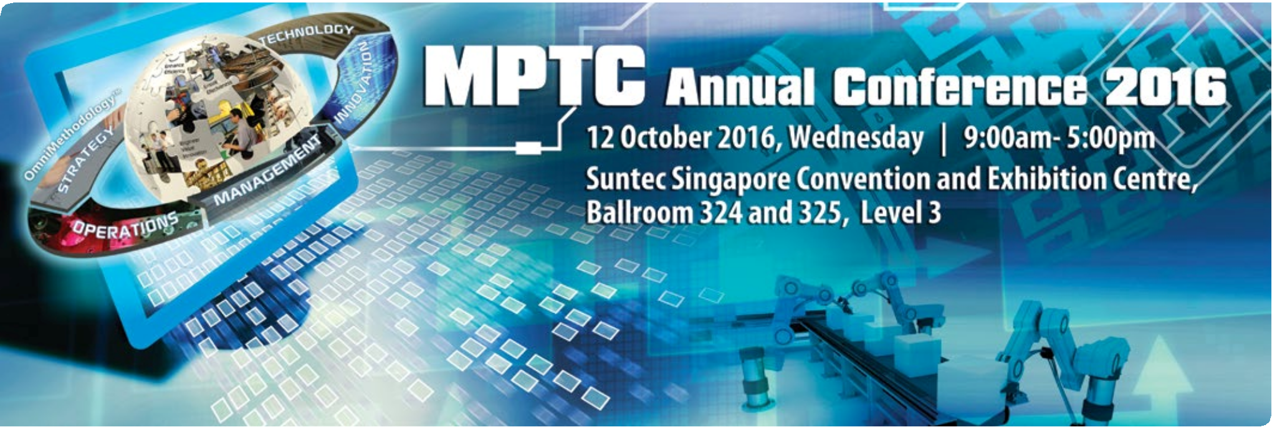

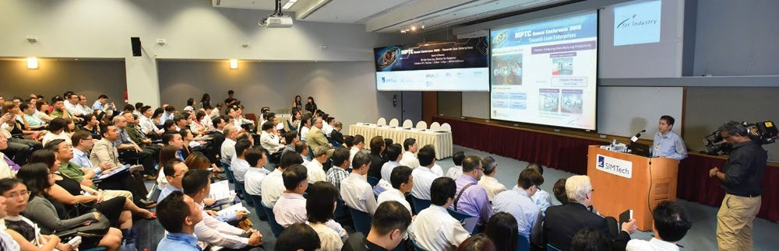

Dear Industry Professionals

Join us for the Manufacturing Productivity Technology Centre (MPTC) Annual Conference
2016, a yearly event to generate awareness of productivity improvements by local enterprises through the use of technology and innovation. In its fifth edition, the theme of MPTC Annual Conference 2016 focuses on Enhancing Productivity through Innovation (subject to confirmation). Industry and technology leaders will be sharing Business Innovation, Operations Innovation including Innovation models and their impact on the industry.

The focus of Innovation is on value creation for the end-customers and reduction in resource utilisation and waste. Though the journey of Innovation for manufacturing and services is critical, the complexity and lack of know-how and capabilities need to be resolved.

These are complemented by insights on productivity improvement through technology and innovation articulated by companies’ representatives from the manufacturing and service sectors. A Panel Discussion will address your queries.

There are two parallel technical sessions in the areas of Business Innovation and Operations Innovation. Productivity discussion sessions for participating companies are also available for you to discuss with our Manufacturing Productivity Associates. Do not miss this opportunity!

MPTC Annual Conference 2016 is a platform for you to capture the emerging models and technologies for Innovation, exchange ideas and initiate collaborations and partnerships.

Website: www.ms-expo.com | Tel: +65 6590 3406 | Email: mse@sph.com.sg
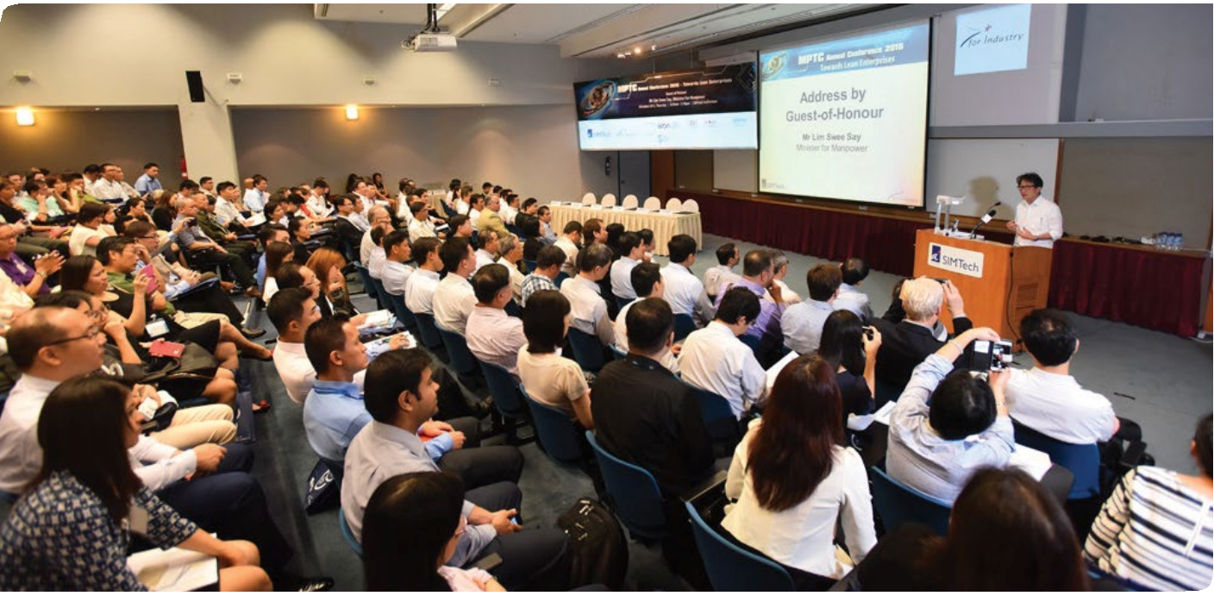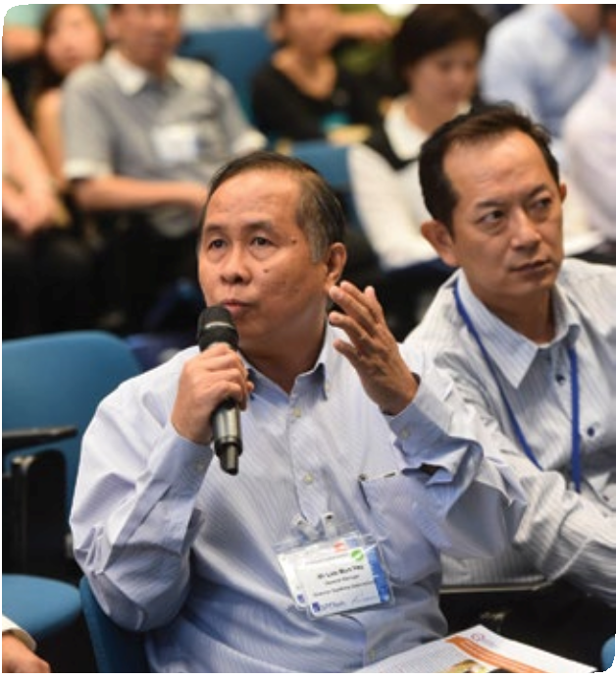

300 attendees mainly CEOs, CTOs, research scientists, academic and engineering professionals from the manufacturing and service industry are expected for the event.

To assist your organisation to transform into Innovative Enterprises with improved productivity, agency and technology providers in automation, design and manufacturing including metrology, are showcasing their products and services in the co-located event, Manufacturing Solutions Expo 2016, organised by the Singapore Manufacturing Federation.

Look out for updates of the complimentary MPTC Annual Conference 2016 in this space.

Yours sincerely,

Dr Lee Eng Wah
Director, Manufacturing Productivity Technology Centre
Singapore Institute of Manufacturing Technology

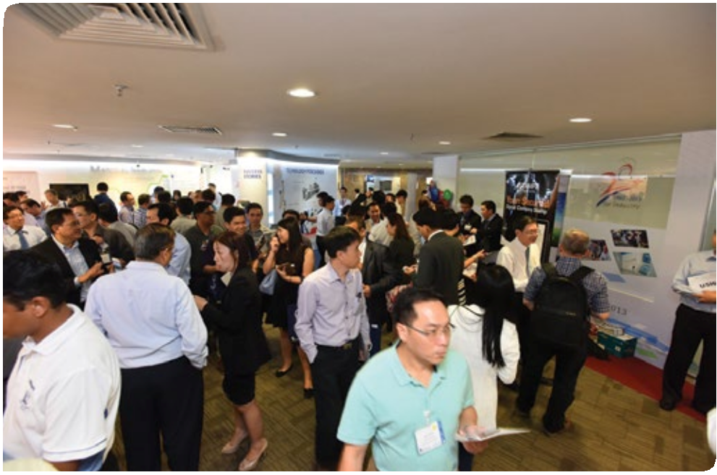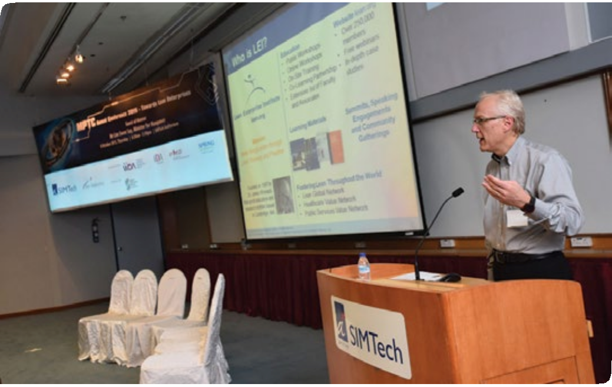SIMTech

Website: www.ms-expo.com | Tel: +65 6590 3406 | Email: mse@sph.com.sg

Strengthen your Brand’s Presence
at Manufacturing Solutions Expo 2016
Reserve your premium space today!

SPACE ONLY (min. 18 sqm)
SHELL SCHEME (min. 9 sqm)

SMF Member Rate -- SGD 470 per sqm
Published Rate -- SGD 500 per sqm
SMF Member Rate -- SGD 530 per sqm
Published Rate -- SGD 560 per sqm

Join the Singapore Pavilion! Enjoy up to a maximum of
50% reimbursement!*
SGD 630 per
sqm
*Administration fee applies. Subject to approval by IE Singapore.
Only companies incorporated and based in Singapore (exclude branch of a foreign company) and locally registered companies qualify. To participate as part of the Singapore Pavilion or to be eligible for the financial assistance under the International Marketing Activities Programme (IMAP). These companies must have at least 3 core business functions listed below:
- Market development and planning
- Manufacturing and others value-added activities
- Banking, finance and treasury functions
- Logistics and shipping management
- Research and development and design function
- Business and investment

Take Advantage of the Unique Business Opportunities and
Vibrant Networking Platform!

• Leverage on the On-site Activities to Enhance your Company’s Profile
• Sponsorship Opportunities ( Various packages available)
• Speaking Opportunities at ManuTech Xchange
• Publicity Opportunities

Leverage your participation on our holistic marketing and advertising platforms!

Editorial
Coverage

Email

Onsite Show Guide
Local & Regional Newspapers, and Relevant Trade Magazines

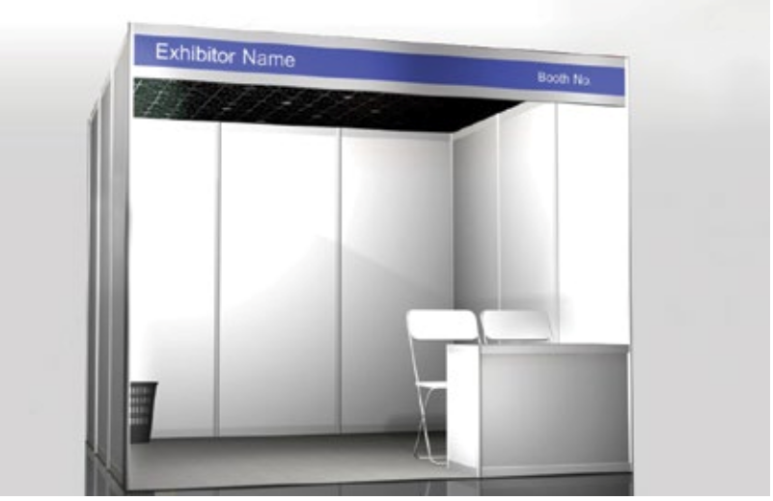Direct
Mailing

Social Media

Mobile App
Business Matching
Programme

